Go to: www.stopbullying.gov/kids/webisodes/index.html
Kid Videos: Watch these videos to learn how KB, Josh, Milton, and their friends deal with kids who bully. After watching each video, take a quiz to see how much you know about bullying. |  | After completing the quiz for each video, write a short summary of the message each video is making.
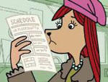 | Webisode 1: KB’s First Day  Being the new girl at school isn’t easy for KB.
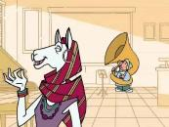 | Webisode 2: Milton’s Dreams  Milton is bullied because he loves to play the tuba.
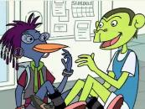 | Webisode 3: Josh North  Brick surprises Josh by complimenting him on a great race.
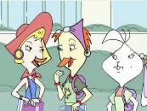 | Webisode 4: Melanie’s Friends  Melanie finds it hard to be friends with someone who bullies others.
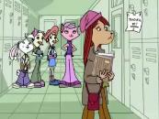 | Webisode 5: KB’s Day  KB doesn’t tell her mom about what is happening at school.
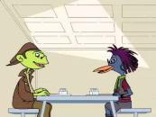 | Webisode 6: Josh & Raven  When Brick bullies Milton, Josh remembers when he was bullied.
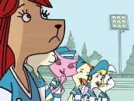 | Webisode 7: Soccer Tryouts  Soccer tryouts don’t go well for KB because of Cassandra’s behavior on the field.
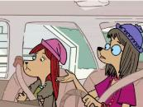 | Webisode 8: KB Withdraws  KB wants to quit soccer because she is afraid of being bullied.
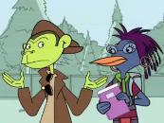 | Webisode 9: Changes of Heart  Josh learns that kids who bully can change and Milton quits the tuba.
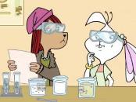 | Webisode 10: KB & Melanie  Mr. Bittner assigns new lab partners to help KB and Melanie.
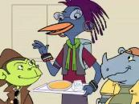 | Webisode 11: Power in Numbers  New friends help Milton stand up to Brick.
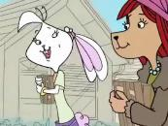 | Webisode 12: Real Friends  KB and Melanie learn the importance of real friends.

